Fredericksburg 2018 Day 2
Tool used to generate map: http://www.gebweb.net/optimap/
Start: 3/3/2018 8:00a at Sunday House Inn (501 East Main Street Fredericksburg, TX 78624)
End: 3/3/2018 1:00p at Lost Maples Café in Utopia (384 Main St, Utopia, TX 78884)

Trip duration:
Part 1: 1.5hrs to Lost Maples; 0.5hrs to Leaky (94 miles)
Part 2: 2 hour loop (97 miles)
Part 3: 30 minutes to Lost Maples Café (22 miles)
Trip length: 213 miles

Fredericksburg to Leaky (part 1)
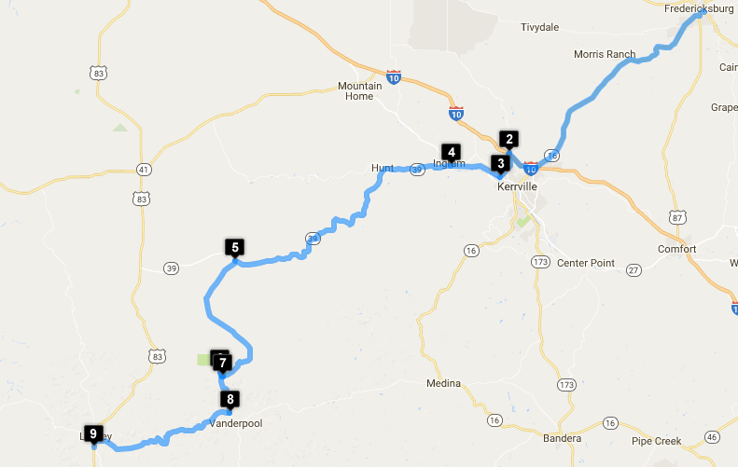

Route Map Points:
(30.2700909, -98.86523869999996)
(30.0900672, -99.15220160000001)
(30.0591396, -99.16472579999999)
(30.0737102, -99.23805219999997)
(29.9529101, -99.55572159999997)
(29.8107329, -99.57781519999997)
(29.8044716, -99.57386559999998)
(29.7588105, -99.56333860000001)
(29.714449, -99.76326340000003)
Way Points to coordinates:
0: (30.2700909, -98.86523869999996)
1: (30.0900672, -99.15220160000001)
2: (30.0591396, -99.16472579999999)
3: (30.0737102, -99.23805219999997)
4: (29.9529101, -99.55572159999997)
5: (29.8107329, -99.57781519999997)
6: (29.8044716, -99.57386559999998)
7: (29.7588105, -99.56333860000001)
8: (29.714449, -99.76326340000003)

Stop Points:
- Lost Maples State Park
- Leakey (breakfast snack & gas, lunch)
  - Gas: Stripes: 844 US-83, Leakey, TX 78873

Part 2: Twisted Sisters Loop
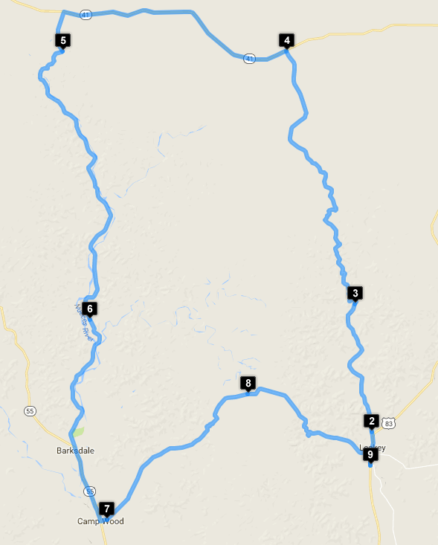

Route Map Points:
(29.714449, -99.76326340000003)
(29.7413525, -99.76211890000002)
(29.8433694, -99.77753869999998)
(30.04616439999999, -99.8407894)
(30.0459295, -100.04756800000001)
(29.8312292, -100.02255100000002)
(29.6710026, -100.00670379999997)
(29.7714659, -99.8766344)
(29.7142876, -99.76325980000001)
Way Points to coordinates:
0: (29.714449, -99.76326340000003)
1: (29.7413525, -99.76211890000002)
2: (29.8433694, -99.77753869999998)
3: (30.04616439999999, -99.8407894)
4: (30.0459295, -100.04756800000001)
5: (29.8312292, -100.02255100000002)
6: (29.6710026, -100.00670379999997)
7: (29.7714659, -99.8766344)
8: (29.7142876, -99.76325980000001)

Part 3: Leaky to Utopia
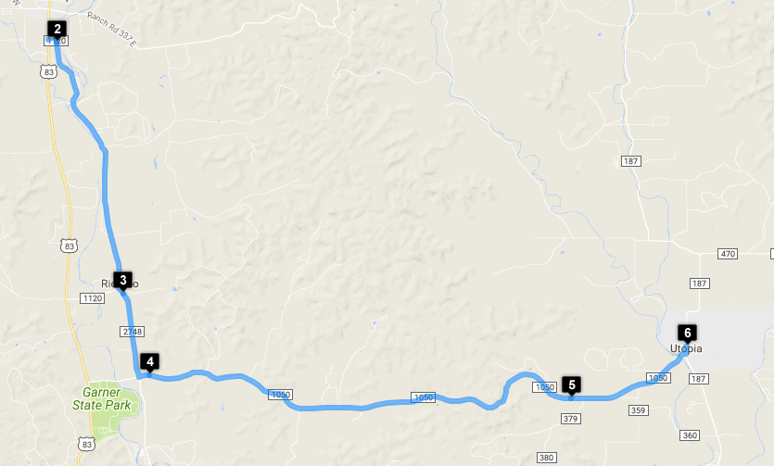

Route Map Points:
(29.714449, -99.76326340000003)
(29.7136583, -99.76023950000001)
(29.6329754, -99.7356034)
(29.6065388, -99.72585679999997)
(29.5992245, -99.56965079999998)
(29.6159482, -99.52683839999997)
Way Points to coordinates:
0: (29.714449, -99.76326340000003)
1: (29.7136583, -99.76023950000001)
2: (29.6329754, -99.7356034)
3: (29.6065388, -99.72585679999997)
4: (29.5992245, -99.56965079999998)
5: (29.6159482, -99.52683839999997)

Part 1: Fredericksburg to Leakey
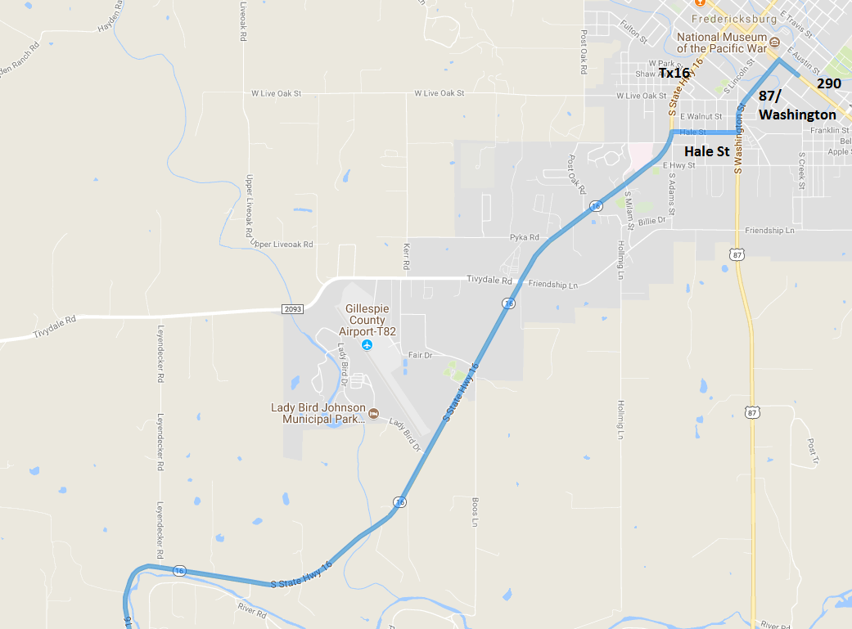
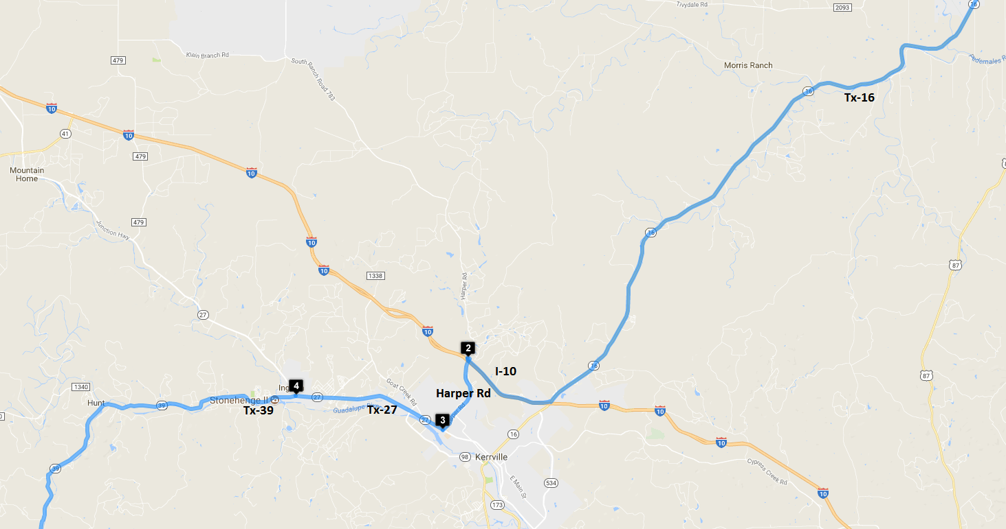

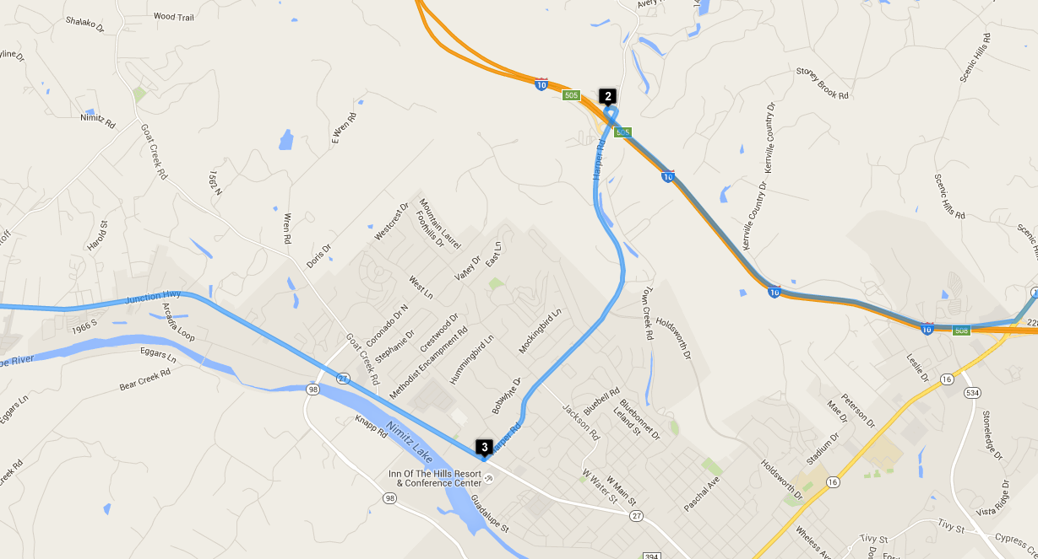
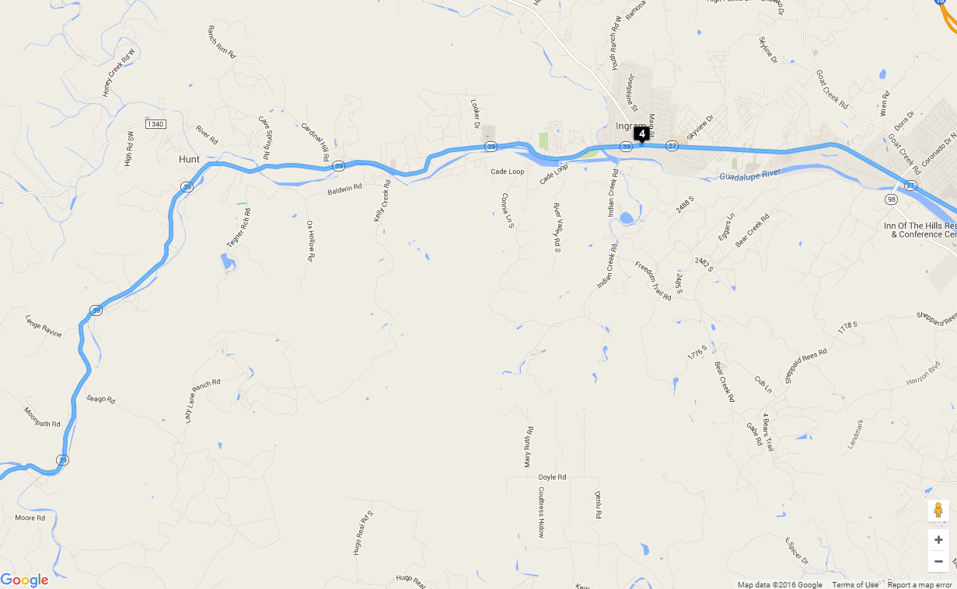
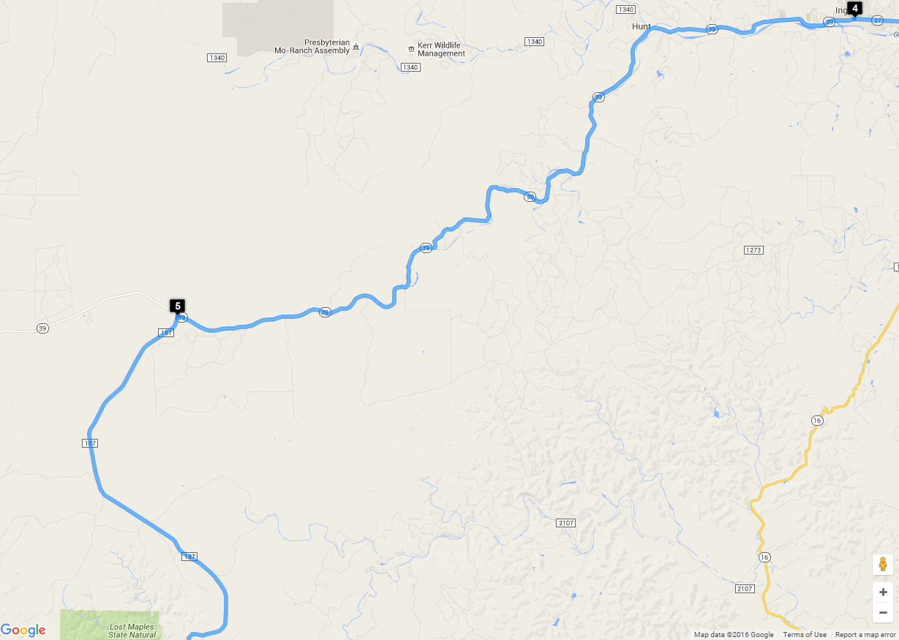
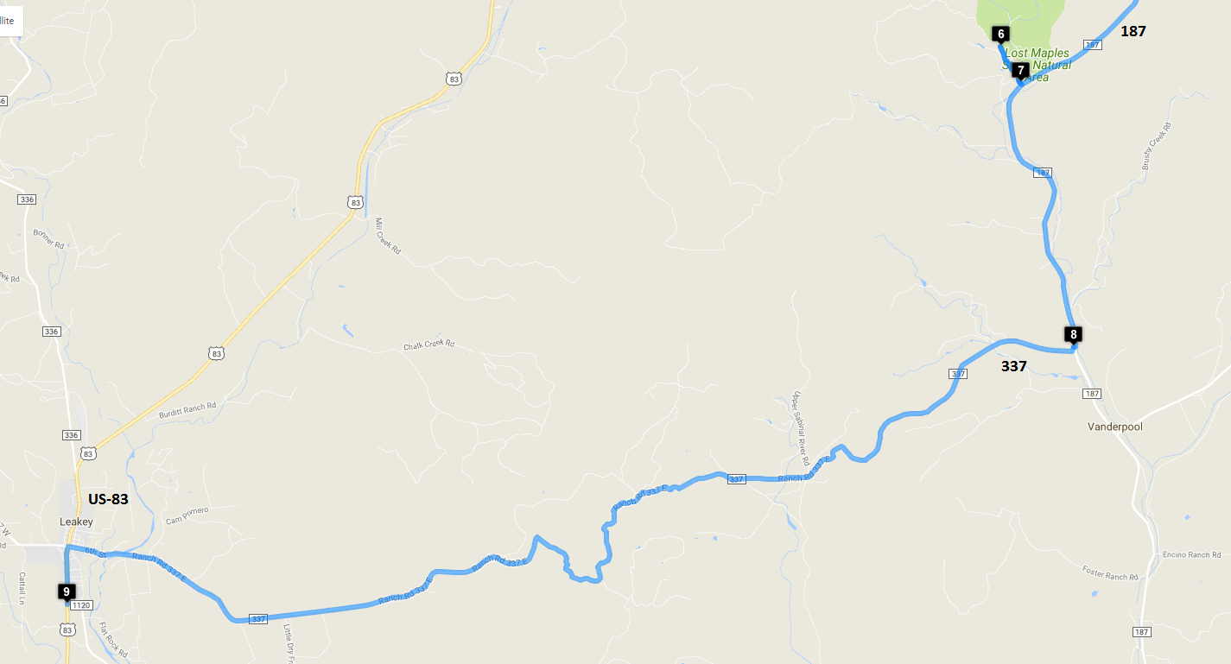

Turn-by-Turn
(30.2700909, -98.86523869999996)
0 sec
Head northwest on E Main St toward N Elk St
0.2 mi
Turn left at the 2nd cross street onto S Washington St
0.5 mi
Turn right onto Hale St
0.4 mi
Turn left onto TX-16 S/S State Hwy 16
21.1 mi
Turn right onto the Frontage Rd ramp
0.3 mi
Merge onto I-10 W
2.5 mi
Take exit 505 for Farm to Market Rd 783 toward Harper
0.2 mi
(30.0900672, -99.15220160000001)
28 min 6 sec
Head northeast
240 ft
Turn right onto Farm to Market Rd 783/Harper Rd
2.5 mi
Turn right onto TX-27 W
20 ft
(30.0591396, -99.16472579999999)
33 min 10 sec
Head northwest on TX-27 W toward Commerce St
4.6 mi
Continue straight onto TX-39 W
0.1 mi
(30.0737102, -99.23805219999997)
41 min 9 sec
Head west on TX-39 W toward W Washington St
26.1 mi
Turn left onto Ranch Rd 187
259 ft
(29.9529101, -99.55572159999997)
1 hrs 17 min
Head south on Ranch Rd 187
14.5 mi
Turn right
0.5 mi
(29.8107329, -99.57781519999997)
1 hrs 34 min
Head southeast toward Ranch Rd 187
0.5 mi
(29.8044716, -99.57386559999998)
1 hrs 36 min
Head southeast toward Ranch Rd 187
157 ft
Turn right onto Ranch Rd 187
3.5 mi
Turn right
128 ft
(29.7588105, -99.56333860000001)
1 hrs 41 min
Head southwest toward FM337/Ranch Rd 337
253 ft
Turn right onto FM337/Ranch Rd 337
Continue to follow Ranch Rd 337
15.0 mi
Turn left onto US-83 S/Market St
Continue to follow US-83 S
0.7 mi
(29.714449, -99.76326340000003)
2 hrs 5 min

Part 2: Twisted Sisters
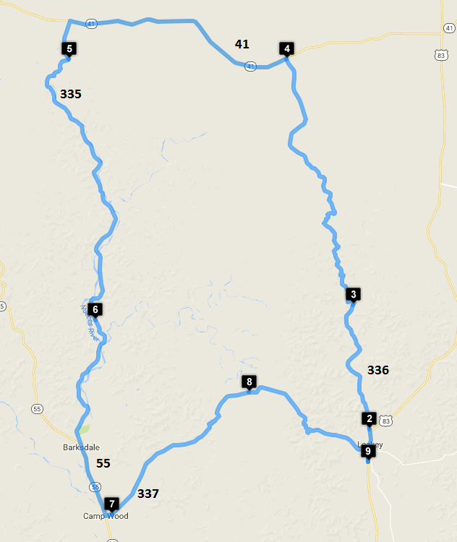

Turn-by-Turn
(29.714449, -99.76326340000003)
0 sec
Head north on US-83 N toward Ranch Rd 1120
1.6 mi
Keep left to continue on Ranch Rd 336 N
0.3 mi
(29.7413525, -99.76211890000002)
3 min 52 sec
Head north on Ranch Rd 336 N toward Airport Rd
8.2 mi
(29.8433694, -99.77753869999998)
15 min 27 sec
Head north on Ranch Rd 336 N toward Kent Creek Rd
18.0 mi
(30.04616439999999, -99.8407894)
42 min 30 sec
Head northwest on Ranch Rd 336 N toward TX-41 W
171 ft
Turn left onto TX-41 W
13.6 mi
Turn left onto Ranch Rd 335
2.3 mi
(30.0459295, -100.04756800000001)
58 min 55 sec
Head south on Ranch Rd 335
18.4 mi
(29.8312292, -100.02255100000002)
1 hrs 21 min
Head south on Ranch Rd 335 toward Ranch Rd 2631
8.3 mi
Turn left onto TX-55 S
4.4 mi
Turn left onto E 4th St
0.4 mi
(29.6710026, -100.00670379999997)
1 hrs 38 min
Head east on E 4th St/Ranch Rd 337 W
Continue to follow Ranch Rd 337 W
11.5 mi
(29.7714659, -99.8766344)
1 hrs 51 min
Head east on Ranch Rd 337 W toward Harper Ranch Rd
9.2 mi
Turn right onto US-83 S/Market St
Continue to follow US-83 S
0.7 mi
(29.7142876, -99.76325980000001)
2 hrs 5 min

Part 3: Leakey to Utopia
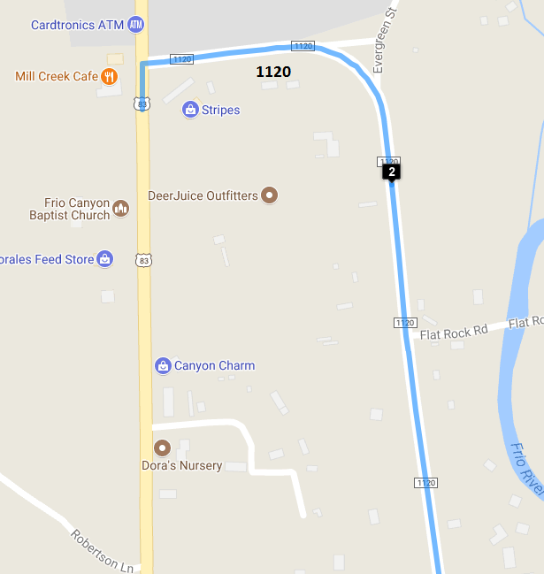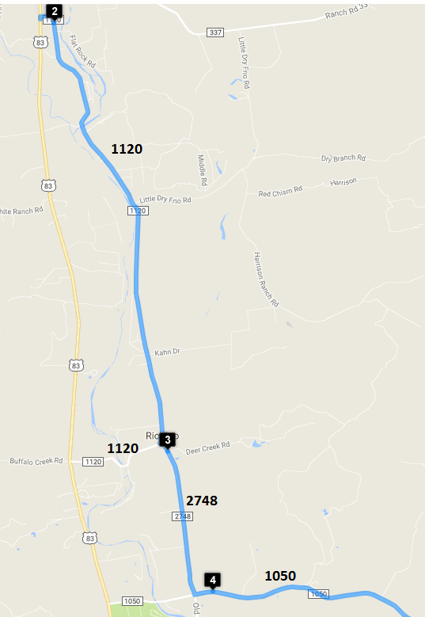
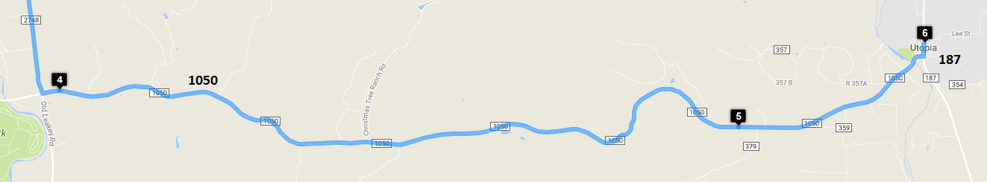
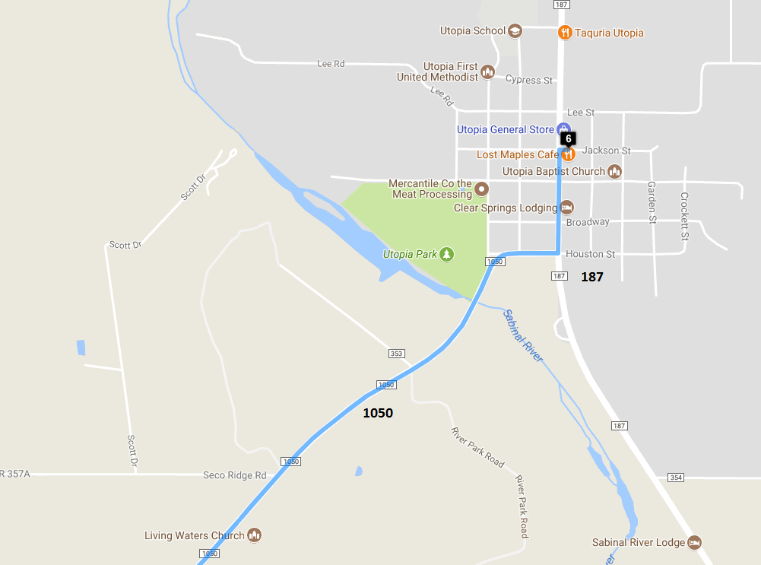

Turn-by-Turn
(29.714449, -99.76326340000003)
0 sec
Head north on US-83 N toward Ranch Rd 1120
177 ft
Turn right onto Ranch Rd 1120
0.3 mi
(29.7136583, -99.76023950000001)
1 min 22 sec
Head south on Ranch Rd 1120 toward Flat Rock Rd
5.9 mi
Turn left onto Ranch Rd 2748
0.2 mi
(29.6329754, -99.7356034)
9 min 37 sec
Head southeast on Ranch Rd 2748 toward Co Rd 351A
1.9 mi
Turn left onto FM 1050 E
0.2 mi
(29.6065388, -99.72585679999997)
12 min 24 sec
Head east on FM 1050 E
10.4 mi
(29.5992245, -99.56965079999998)
23 min 48 sec
Head east on FM 1050 E toward Co Rd 379
2.8 mi
Turn right onto Houston St
0.1 mi
Turn left onto Ranch Rd 187/Main St
0.2 mi
Turn right at the 3rd cross street onto Jackson St
79 ft
(29.6159482, -99.52683839999997)
28 min 1 sec

Post-Lunch, Return to Fredericksburg
Distance: 74 miles
Time: 1 hrs 35 min
Route Map Points
(29.6159482, -99.52683839999997)
(29.6738848, -99.35666570000001)
(29.6690878, -99.2309621)
(29.7331159, -99.11490470000001)
(29.7964335, -99.24818370000003)
(29.8858139, -99.2732752)
(29.96937389999999, -99.14969029999997)
(30.01832589999999, -99.116308)
(30.0686251, -99.11343920000002)
Way Points
0: (29.6159482, -99.52683839999997)
1: (29.6738848, -99.35666570000001)
2: (29.6690878, -99.2309621)
3: (29.7331159, -99.11490470000001)
4: (29.7964335, -99.24818370000003)
5: (29.8858139, -99.2732752)
6: (29.96937389999999, -99.14969029999997)
7: (30.01832589999999, -99.116308)
8: (30.0686251, -99.11343920000002)
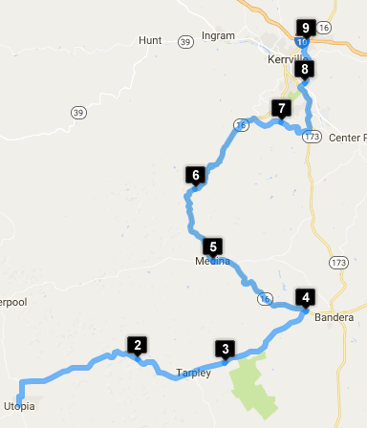

Maps
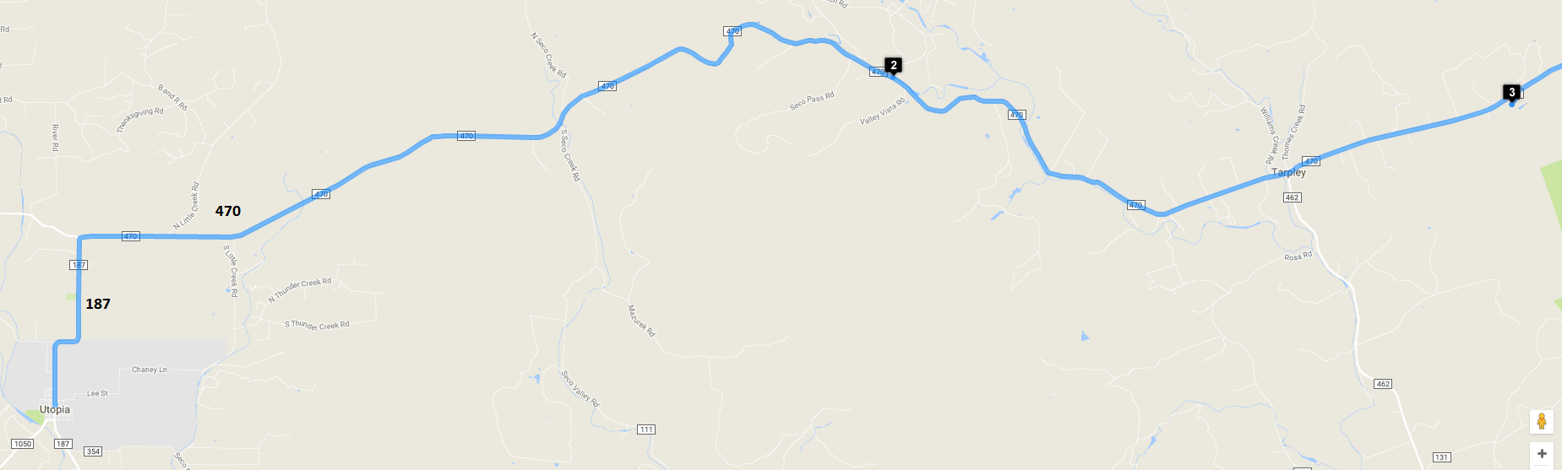
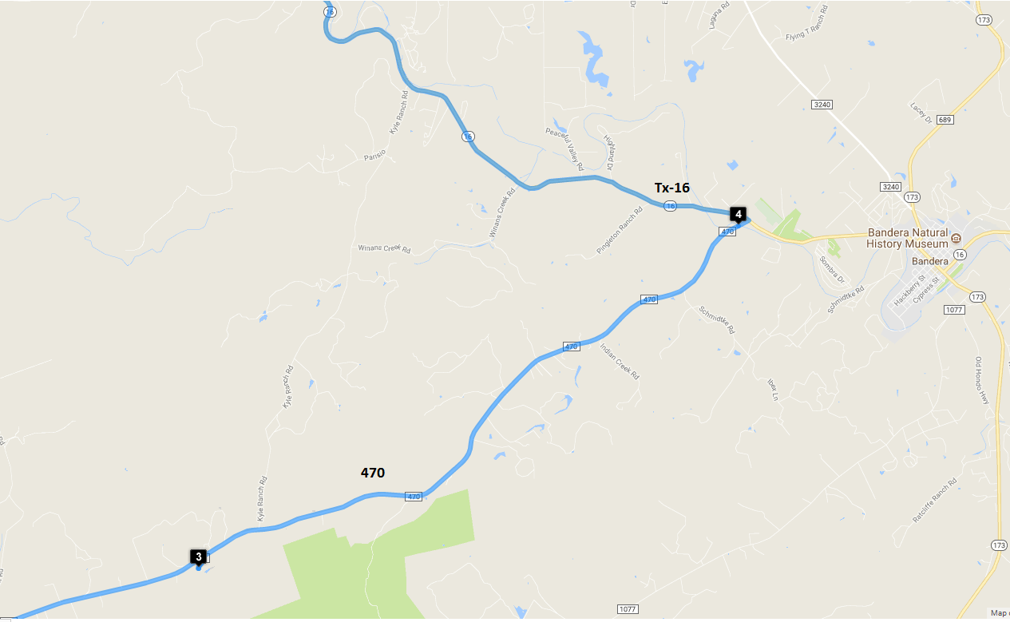
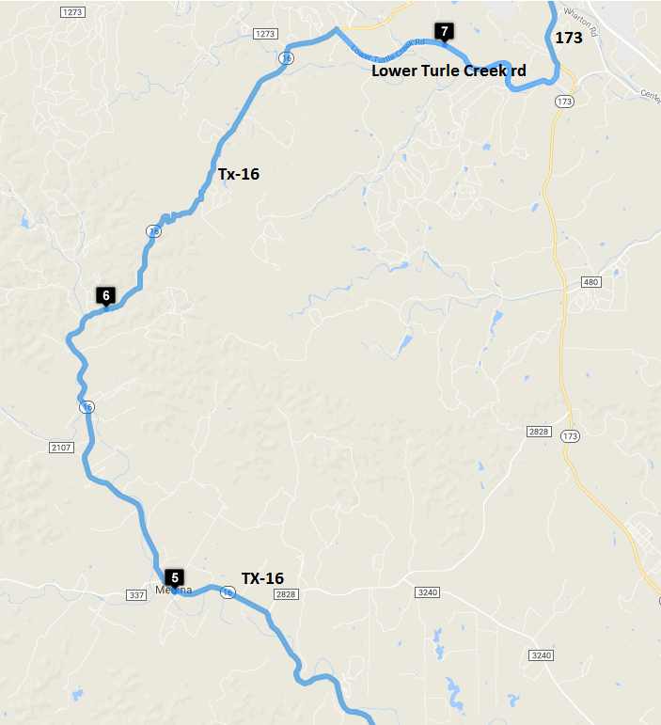
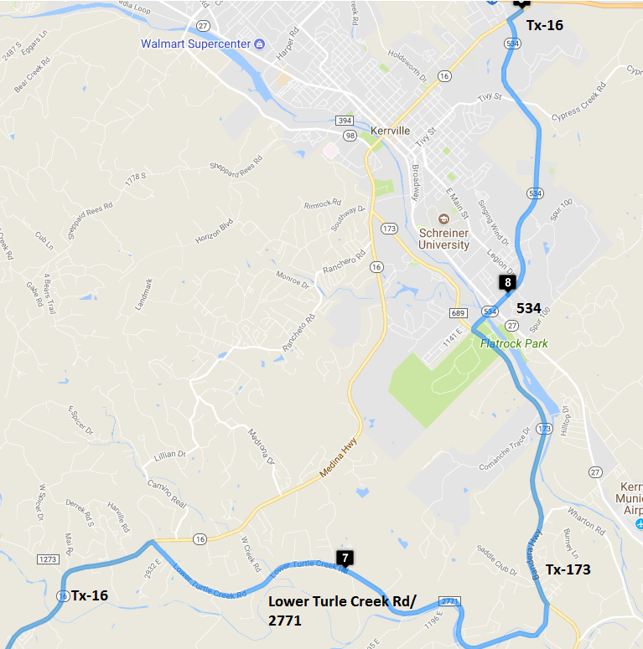
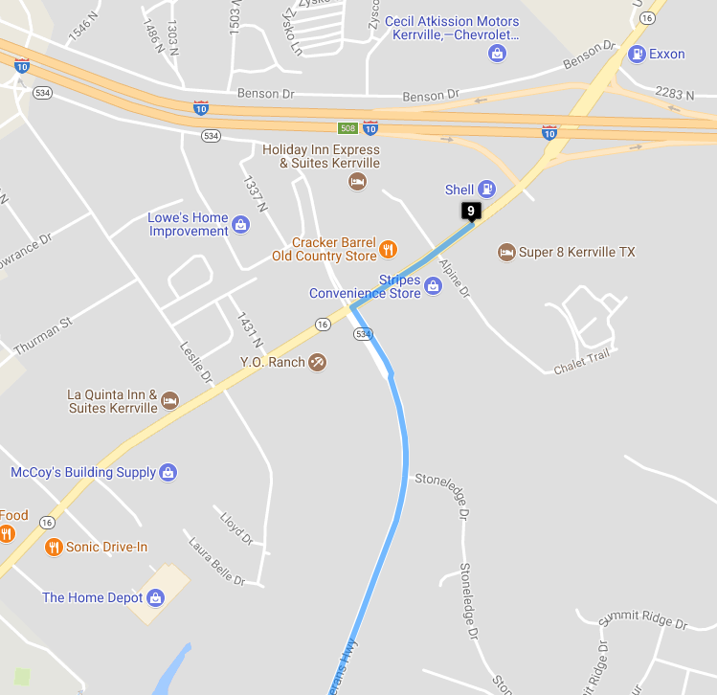

Turn-by-Turn
(29.6159482, -99.52683839999997)
0 sec
Head west on Jackson St toward Main St
79 ft
Turn right at the 1st cross street onto Ranch Rd 187/Main St
Continue to follow Ranch Rd 187
2.2 mi
Turn right onto Ranch Rd 470
11.2 mi
(29.6738848, -99.35666570000001)
16 min 43 sec
Head southeast on Ranch Rd 470 toward Valley Vista Rd
8.7 mi
Turn right
0.2 mi
(29.6690878, -99.2309621)
27 min 49 sec
Head north toward Ranch Rd 470
0.2 mi
Turn right onto Ranch Rd 470
8.6 mi
(29.7331159, -99.11490470000001)
37 min 42 sec
Head northeast on Ranch Rd 470 toward TX-16 S
0.2 mi
Turn left onto TX-16 N
10.5 mi
Turn left onto Sheppard Ave
246 ft
Turn right onto Hackberry St
Destination will be on the right
98 ft
(29.7964335, -99.24818370000003)
50 min 54 sec
Head northwest on Hackberry St toward Parker Ave
79 ft
Turn right at the 1st cross street at Parker Ave
217 ft
Turn left onto TX-16 N
Destination will be on the right
7.8 mi
(29.8858139, -99.2732752)
1 hrs 3 min
Head east on TX-16 N
9.1 mi
Turn right onto Farm to Market Rd 2771/Ranch Rd 2771 (signs for Farm to Market Road 2771 E)
Continue to follow Ranch Rd 2771
Destination will be on the right
2.7 mi
(29.96937389999999, -99.14969029999997)
1 hrs 19 min
Head east on Lower Turtle Creek Rd toward Estes Park Ln
3.5 mi
Turn left onto TX-173 N
3.8 mi
Turn right onto TX-534 Loop N
Destination will be on the left
0.6 mi
(30.01832589999999, -99.116308)
1 hrs 29 min
Head northeast on TX-534 Loop N toward 1594 N
3.7 mi
Turn right onto Fredericksburg Rd/Sidney Baker St
Destination will be on the left
0.2 mi
(30.0686251, -99.11343920000002)
1 hrs 35 min

